# Wind Power Project - Use Case

## Problem/”Pitch”

Energy estimation is an important need for any country. Countries operate on a variety of different energy sources that need to be balanced out due to the unreliability of some; solar is impactful when the weather allows it, wind energy’s production also fluctuates based on weather. The estimations and data are fed through a smart grid algorithm that allows for an efficient balancing of power estimation over a given region to meet electricity demands and electrical stability requirements.

A loss of power stability can create enormous costs on a personal, business and national scale, with effects on homeowners ranging from having to replace spoiled food, to property damage; businesses can lose productivity and information from their data centres.

## Data

### Wind Turbine Data

Here is the proposed dataset(s) to be used from Engie (Wind Turbines, Open License):

[Wind Turbine Information](https://opendata-renewables.engie.com/explore/dataset/6eeb7f50-97f7-4ab2-8d36-c6d9f9491d84/information) -> Gives the kW potential generation per hour, and the altitude.

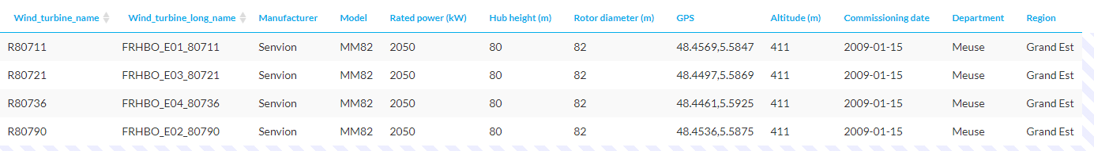

[Descriptions for Data Tables 3 and 4 below](https://opendata-renewables.engie.com/explore/dataset/39490fd2-04a2-4622-9042-ce4dd34c2a58/information) -> Various useful data for this project. The units for any measurements, the long name so we can research it etc.

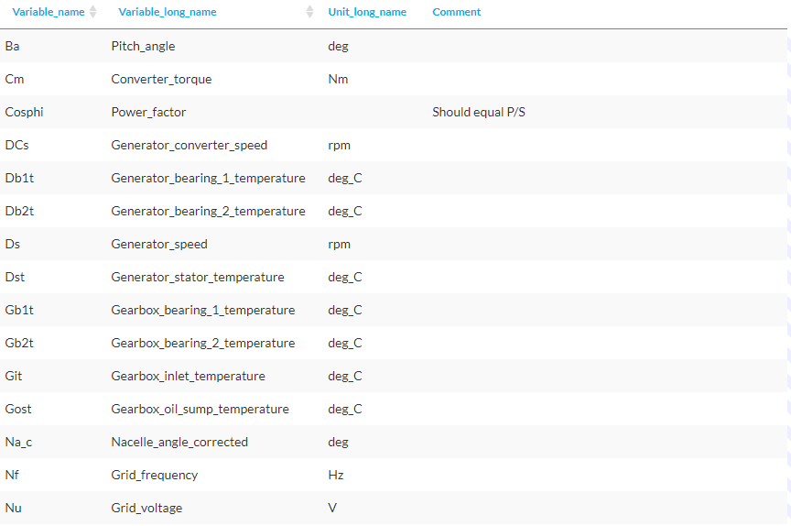

["Data Table 3" / La Haute 2013-2016 Data](https://opendata-renewables.engie.com/explore/dataset/d543716b-368d-4c53-8fb1-55addbe8d3ad/information) -> The data generation, weather conditions etc for 2013-2016 from the wind turbines. Features four turbines.

["Data Table 4" / La Haute 2017-2020 Data](https://opendata-renewables.engie.com/explore/dataset/01c55756-5cd6-4f60-9f63-2d771bb25a1a/information) -> The data generation, weather conditions etc for 2017-2020 from the wind turbines. Features four turbines.

### Weather Data

This will have to be scraped or acquired from somewhere else. Important information would likely be the wind speed.

## Output

The output should be relatively simple as it’s going into a database. Perhaps it could be done in the case of:

| Datetime | Turbine | Estimated | Last Week |
| --- | --- | --- | --- |
| 2023-03-01 09:00:00 | R80736 | 6kWh | 8kWh |
| 2023-03-01 09:15:00 | R80736 | 5kWh | 4kWh |

This is just an example. We should probably speak about it more - “Last Week” can exist or not exist for the sake of visualisation.

